Individual Essay

Student ID: 39226441

LZPMP001: Programming clinic

**Developed individual project**

***Event Management System***

*The Event Management System is a complete app made to make event organization and management easier. This system helps with planning events, registering attendees, keeping track of events. Its goal is to make things simpler for event planners and create a smooth experience for everyone involved.*

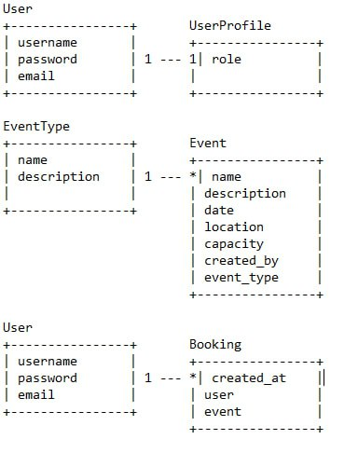

*Class Diagram of EMS*

**Development instruments**

* *Python*
* *Django Framework*
* *SQLite3*
* *Postman*
* *React*
* *JavaScript*